**Original sound signal**

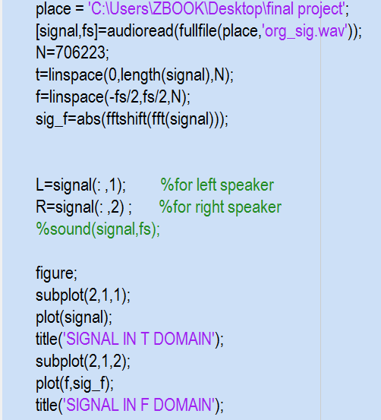**CODE**

**OUTPUT**

**Channel : Delta function**

CONV

CODE

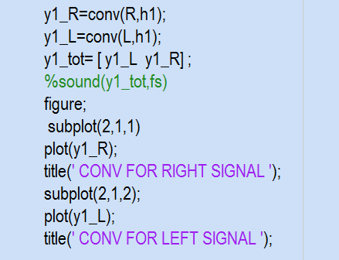

OUTPUT



NOISE

CODE

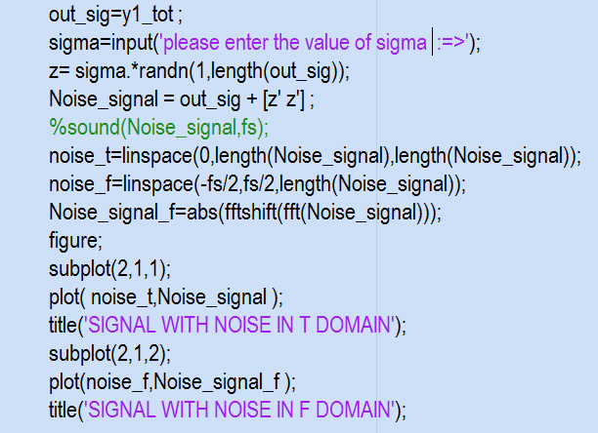

OUTPUT



FILTER

CODE

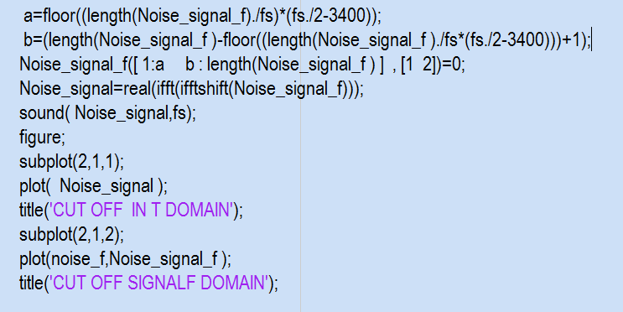

OUTPUT



**Channel : exp(-2pi*5000t)**

CONV

CODE

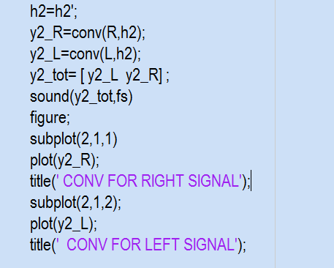

OUTPUT



NOISE

CODE

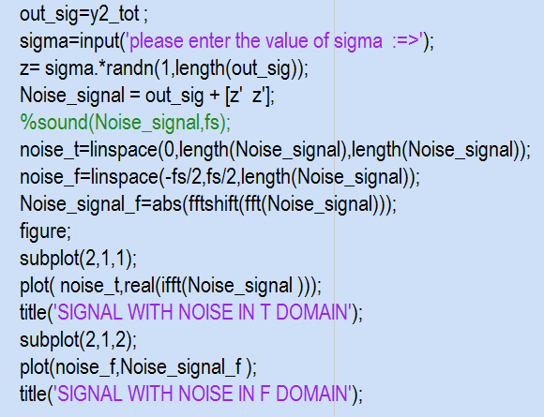

OUTPUT

FILTER

CODE



OUTPUT



**Channel : exp(-2pi*1000t)**

CONV

CODE

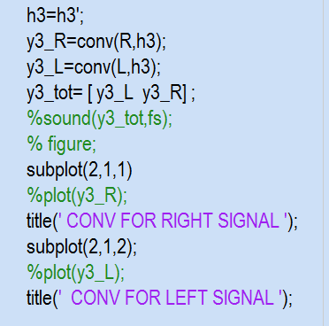

OUTPUT

NOISE

CODE

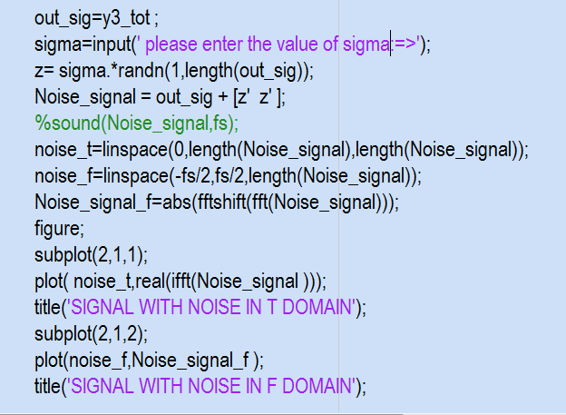

OUTPUT



FILTER

CODE



OUTPUT



**Channel : given impulse response in figure 2**

CONV

CODE

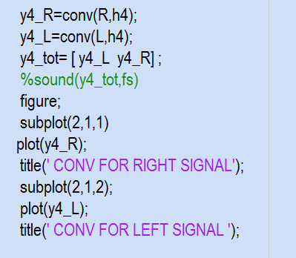

OUTPUT



NOISE

CODE

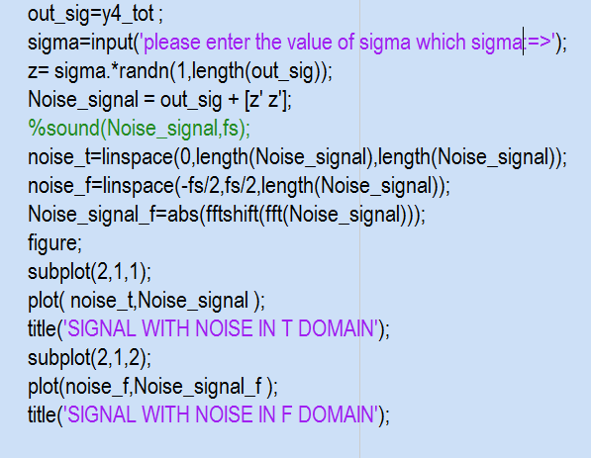

OUTPUT



FILTER

CODE



OUTPUT

Hint: sigma in all cases =.01